ME-452 Robotics

Take Home Assignment



Joint Torques using Lagrangian Transformation

Name: Taha Mahmood

Registration No: 2017472

Dated: 7th May 2021

Submitted to:- Dr. Abid Imran

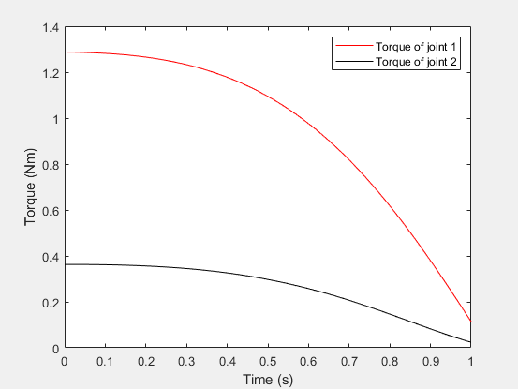MATLAB Figures of Torque of joint 1 and 2.